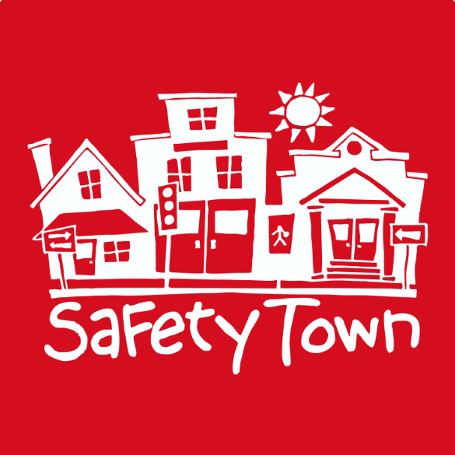
SAFETY TOWN 2025 our 50th year
This special course designed for children entering Kindergarten in the Fall 2025, is 5 days of learning how to be safe and becoming familiar with safety services guided by teen instructors, many of whom are Safety Town graduates themselves! The course is organized into four 30-minute activities. Topics include crossing the street, fire, bike safety, stranger safety AND be visited by community service & safety personnel. Children will learn by classroom instruction, video and practice in ‘cars’ & on foot in “The Town”. On Thursday, drop off and pick up at the Riverview Pool, 101 S. 1st St. We will learn pool safety and save sometime to swim. Graduation will be on Friday at 11:15am outside in the Town. Parents will not be allowed in the building. [Note: all students must be toilet trained.]
(Note: Thursday drop off and pick up at the Riverview Pool!)

DAYS: Monday thru Friday

Session #1 July 14-18 MORNINGS 9am-11:30am- online and in person registration closes July 10
Drop off by 9am and Pick up at 11:30am
Session #2 July 21-25 MORNINGS 9am-11:30am- online and in person registration closes July 17
Drop off by 9am and Pick up at 11:30am
Session #3 July 28-Aug 1 MORNINGS 9am-11:30am- online and in person registration closes July 24
Drop off by 9am and Pick up at 11:30am
WHERE: Ericksen Community Center- 1401 11th Ave. N. Clinton, IA
COST: $35 per child - Checks payable to: ‘Clinton Parks & Recreation Dept.’ [Limit - 40 students per session]
REGISTER AT: Parks & Recreation Department-Ericksen Community Center, 1401 11th Avenue North, Clinton. Office hours: Monday-Friday 8am-5pm.
REGISTER ONLINE: clintoniowa.recdesk.com/Community/Program

Child’s Name: Gender: M / F Birth date:
Parent/Guardian Name: Phone:
Address: City
EMERGENCY CONTACT: (Please list someone we can contact if you are not available.)
Name: Phone:
Relationship: [The teen instructors will help the children memorize all this information.]
My child will attend Kindergarten in the fall at: (please circle) Other __________
Erie Bluff Eagle Heights Camanche DeWitt Fulton Prince of Peace Easton Valley Jefferson Whittier Northeast Maquoketa Unity Home School Calamus/Wheatland West Carroll
My child’s YOUTH size T-shirt -XS (5)____ Small (6-8)____ Med (10-12) ____ Large(14-16)_____
Safety Town has my consent to photograph my child for publicity: YES NO.
ALLERGIES OR PHYSICAL LIMITATIONS Please list any conditions your child has that may affect your child’s enjoyment of Safety Town.

I give my consent for my child to attend Safety Town.
(Parent Signature. - MUST BE SIGNED.)

*All Safety Town students must be entering Kindergarten in the fall. First time registrations only. All Safety Town students must be toilet trained.
Is there anyone that should not pick up my child? YES or NO If yes, let us know ___________________________
_________________________________________________________________________________________________________

